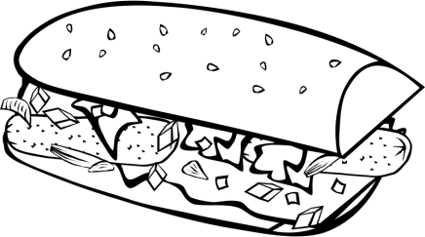MMA Sub Sale

So what is the MMA? The acronym stands for Mechanicsburg Music Alliance, which is a non-profit organization to support & promote ALL of the music programs offered. You are an integral part of the Mechanicsburg Music Alliance by being involved in a music program at the Mechanicsburg School District and we support YOU all the way from elementary to high school!

This year we are looking at a cost of approximately $100,000 to support all of our music programs. These funds support instruments, uniforms, transportation, clinicians and more. We need your help to raise these funds! Stays tuned to our emails for support at events, and contribute your time and effort in supporting our various fundraisers throughout the year.

Your GOAL is to sell AT LEAST 10 subs! Subs sell for $6 and pretzel sandwiches sell for $5. The more you sell, the more we earn, and the more we can give back to our music programs. Be sure to ask your parents, family, teachers, and neighbors today to invest in our long tradition of one of the finest music programs in the state.

If you would prefer to make a tax deductible donation, please do so! Each student should have one check for their order payable to MMA to turn into their music teacher with the order form. Contact Lisa Waldman (MMA Member at Large) (717)-580-3836 or waldmanlisa5@gmail.com with any questions.

SUB ORDERS DUE- Oct 9th to YOUR MUSIC instructor at YOUR school

DELIVERY DATE- October 18th @HS Band hallway 5-6 pm

